This is an example for color inspection using FFD.

1. Intention of lab is to find defects as in image

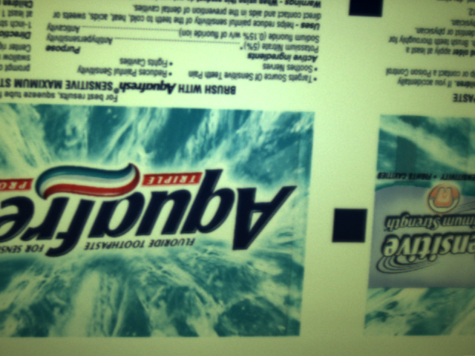

1. Use a 640x480 color emulator for this example
2. Step 1 is to create a fixture on the Aquafresh label
3. Step 2 is to use TrainFlawModel and train on image001.bmp
4. Next step is to have the Flex Model. For this example use default as the recipe as well.
5. Next step is to detect flaws. For this example set the contrast to be 20, find both area defects and missing edges.
6. Defects should be found in images 11,12,13,14, 16, 17, 18, 20,21, 129,138, 152, 153, 154, 155, 156, 157, 162, 203, 208